|  |  |  |  |
| --- | --- | --- | --- |
| **CS102** | **Spring 2015/2016** | Project Group | G3A |
| Instructor: | **Hakan Ferhatosmanoğlu** |
| Assistant: | Hüseyin Celal Öner |

|  |  |  |
| --- | --- | --- |
| **Criteria** | **TA/Grader** | **Instructor** |
| Presentation |  |  |
|  |  |  |
|  |  |  |
|  |  |  |
| Overall |  |  |

~ UGOTTIME? ~

102ERS

Berfu Anıl

**Berk Mandıracıoğlu**

**Emre Gürçay**

**Kaan Sancak**

**Mehmet Ali Altuntaş**

**Özkan Tuğberk Kartal**

|  |
| --- |
| Report Type  ( Requirement & UI/(version 1.2) )  17 March 2016 |

# Introduction

View this template in "Print Layout" form. To use it, begin by editing the preceding section to include information related to your project & the report you are writing (for help, press F1 when the text cursor is in a field.)

Using Styles

As far as possible, do not change any of the formatting, but rather use the existing styles. For example, place the cursor in the text "Using Styles" above. Notice the Style is "Normal." Try changing it to "Heading 2," then to "Heading 1." Note the numbering of subsequent sections is changed automatically.

# Details

The real work goes here! Replace section titles with something relevant to your report.

## Requirements

## User Interface Design

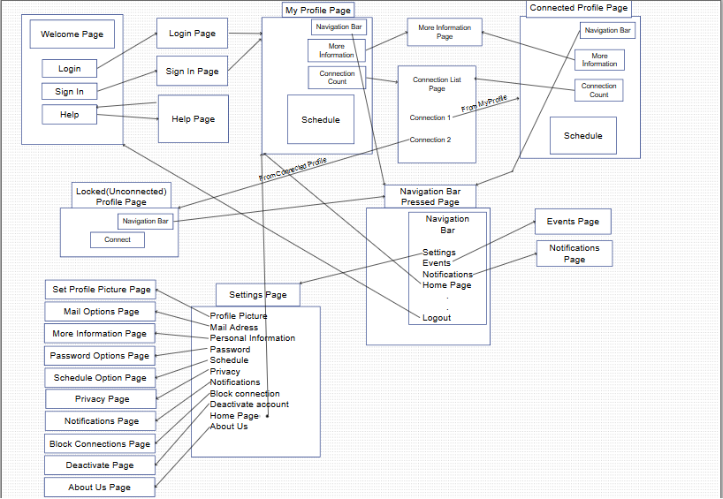

## Story map

Once you understand the basics, you may want to switch to "Outline" view to sort out your ideas before returning to the "Page Layout" view to write the actual content. If you learn to use styles, outlines and endnotes properly, then Word sorts out the numbering, formatting, etc. for you. Try inserting and deleting some of the references from the text and notice again how the other numbers change automatically. Having the machine do the layout and such numbering automatically, enables you to concentrate on what is really important, the content. Neat and very professional looking, eh?

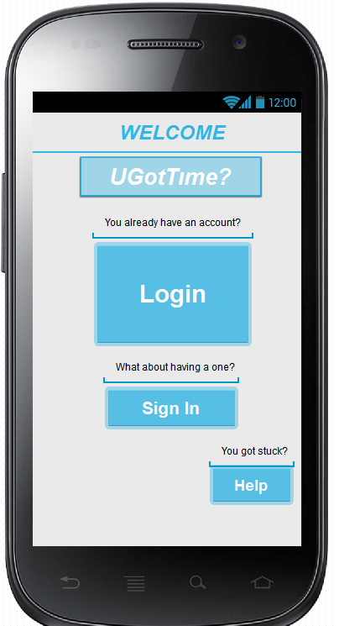**Welcome page**

This page contains the name of application, i.e., “UGotTime?”.

If the user has an account (s)he can click “Login” button.

Otherwise, (s)he can click “Sign In” button to get a new account.

If (s)he thinks (s)he need help “Help” button can be clicked.

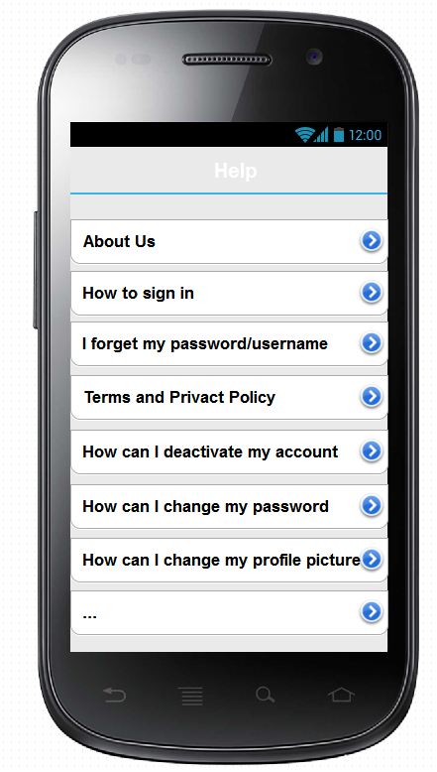**Help Page**

In help page, users can get help if they have some problems with UGotTime. They can learn facts “About Us”. They can learn how to sign in and what is the conditions for signing in to our app. If they have problems with their password or username they can learn how to recover them. They can read our terms and privacy policy which is on the processes for now. They can also learn how to deactivate their account, change their password or profile picture and more other options (in the processes)

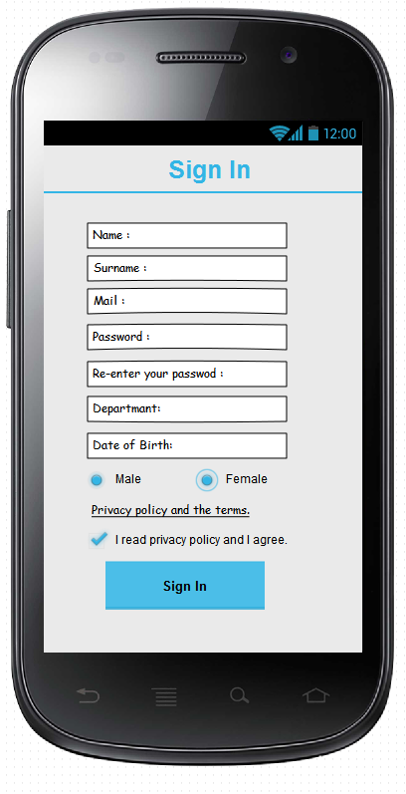

**Sign In Page**

In sign in page the user enters his/her name, surname.

The user then enters his/her mail address. In the mail address section, only the mails that have Bilkent ug extensions can be acceptable (e.g. abc @ug.bilkent.edu.tr) other users with different extensions rather than Bilkent extensions cannot get a confirmation mail.

The user must enter the password. This password must contain at least four characters. After the password is entered, for confirmation the user will enter it one more time to the section “Re-enter your password:”.

The user must enter the department and date of birth.

It is enough to click “Privacy policy and the terms.” to learn the conditions which must be agreed to sign in this program.

The user must click the options of “Male” or “Female” to identify gender and finally after the clicking “I read privacy policy and I agree.”, the “Sign In” option will be available to him/her and (s)he can click it to finish signing process.

After the user clicks the sign in button with valid information, a confirmation mail will be sent to the his/her Bilkent mail account to confirm whether user is a Bilkent student. (All the people who were or are going to Bilkent is acceptable, that means that graduated students can also join our network.)

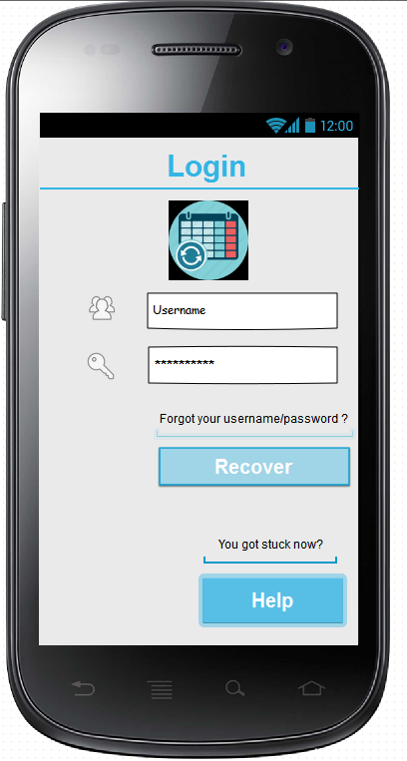**Login Page**

If the user has already had an account, (s)he can enter first his/her user name and password.

If the user forgets his/her password/username, (s)he can click the recover button to recover them.

The “Help” button is also available as it is on “Sign in” page.

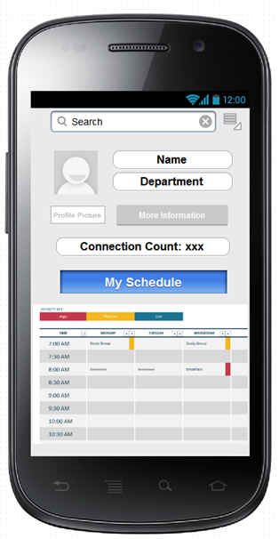**User’s Main Page**

User can see and choose profile picture (s)he desires (To change profile picture user must click to the menu bar and then setting, user can change its picture by clicking profile picture options as it can be seen in next pages.)

User can see his/her schedule at this page.

User can search for any people with using the seek bar above.

At the place where “Connection Count” text is seen how many friends’ user has can be seen.

Users can see more options by clicking the menu bar at the top of the right corner.

Much more information can be found about user via clicking the “More Information” button.

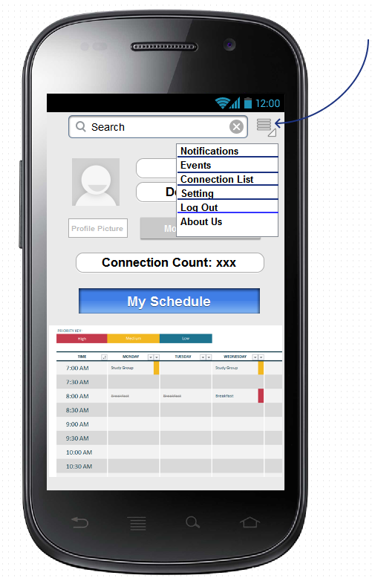**Menu/Navigation Bar**

By clicking the menu icon which is at the top of the right corner of the screen users can see different options of functions. These functions are defined more detailed on the next pages. Briefly this navigation bar helps users to control their arrangements and setting about the applications. Users can see and arrange their notifications, events, connection list and settings. Moreover, users can logout from the “Log Out” button which is on the Navigation bar.

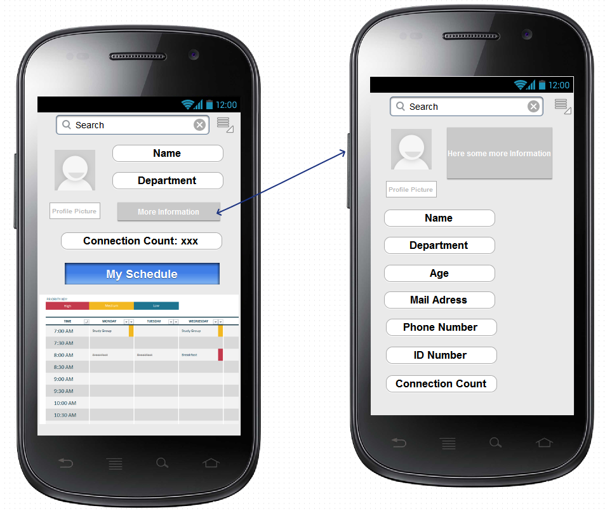**More Information**

By clicking the “More information” button users can see detailed version of their information, to prevent an unwanted situation, users can arrange privacy of their information from setting (as it is declared in next pages)

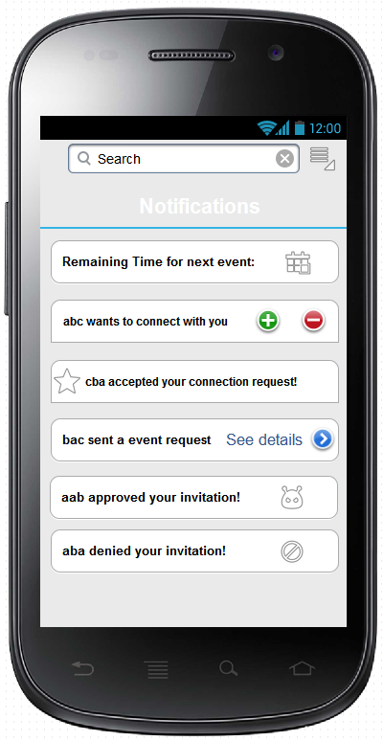

**Navigation Bar-Notifications**

By selecting the notifications from navigation bar, users can see their latest news and notifications.

Users can see who added them.

Users can see the closest joined event.

Users can see their invitations and responds of their invitations.

Users can see their friend request and approvals.

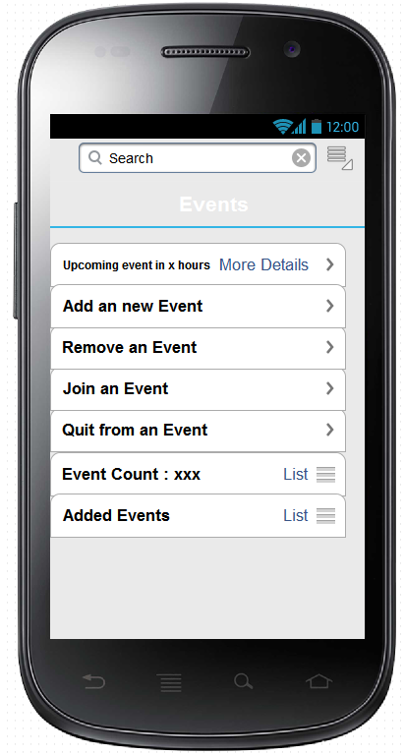**Navigation Bar- Events**

By selecting events from navigation bar, users can see a list of event functions.

First functions provide a remainder of closest events which has the same function as the remainder which is in the notifications however this function also allows users to see more detailed version of the closest event (name, time, location etc.)

Secondly Users can add a new event by clicking “Add a new event” button and invite their friends to that event. (It can be seen at next pages)

Users can remove an event from the application, however to be able to remove an event user must be the one who created the event.

Users can join an event or quit from one.

Users can also see their event count from events section but this section also provides a list which user can see the attempted events.

Users can also see added events list to their schedule here.

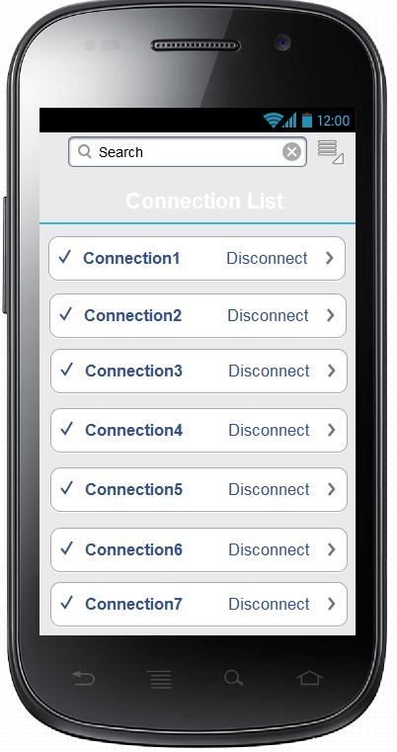 **Navigation Bar-Connection List**

This page pops up when “Connection List” button is clicked from navigation bar.

As seen all connections are listed and they can be seen with clicking the corresponding connection button like “Connection1”, “Connection2” and there is an option “Disconnect” which is available for all connections. When “Disconnect” is clicked it means that disconnected connection is not a friend(connection) of the user any longer.

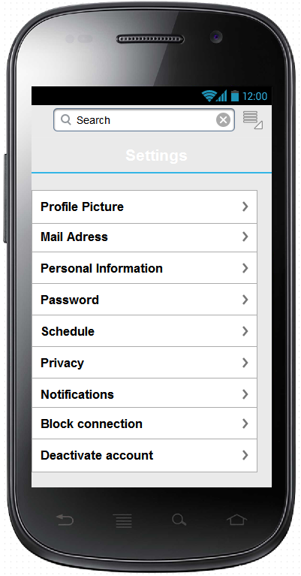**Navigation Bar-Settings**

By clicking the settings from navigation bar, users can see different settings of their information and preferences Users can change or see their profile picture, mail adress, personal information, password, schedule, privacy setting, notification setting from settings. Moreover, they can deactivate their account or block a connection from settings. You can see the detailed version of these functions in following pages.

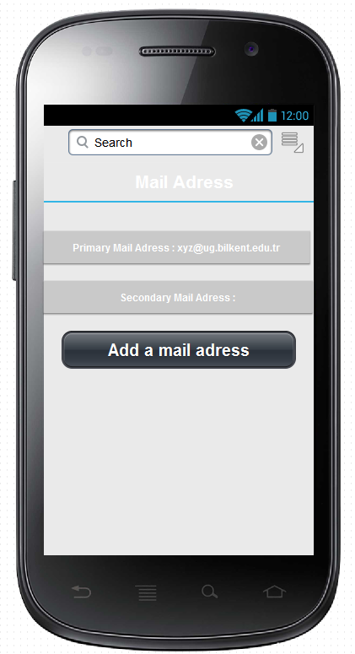**Settings-Mail Adress**

To use our application all users must have Bilkent mail adresses to confirm that they are/ were a student at Bilkent. However if a user wants to get his notifications/mails to his/her own mail adress, that user can add a secondry mail adress from Mail Adress section by Clicking the “Add a mail adress button”. A confirmation mail will be sent to the mail adress as expected. If the user wants to delete the secondry mail adress, user must click on the mail adress and delete it.

Note that primary(Bilkent mail adress) cannot be deleted.

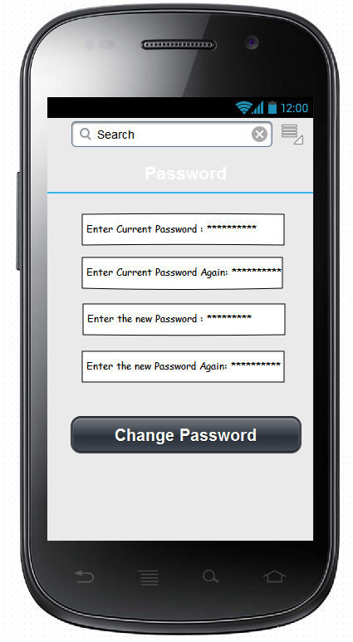

**Settings-Password**

Users can change their password by entering their current password two times to the given locations and entering their new passwords to given locations. After user clicks the “Change Password” button a confirmation mail will be sent to the user’s mail adress to approve that the user is the right student who owns the account.

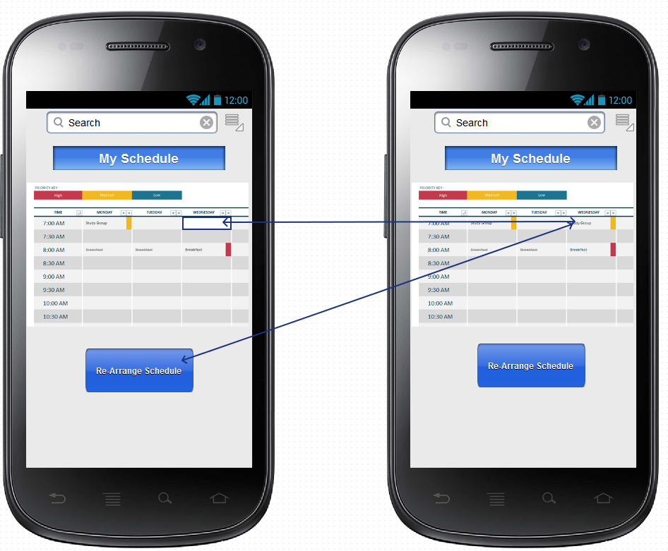**Setting - Schedule**

Users can arrange their schedule from this function to do that, users must click the re-arrange schedule and select the time period which is going to be changed as it is seen in the picture. It is a working in progress thus we can add different options to this function in next stages of our project.

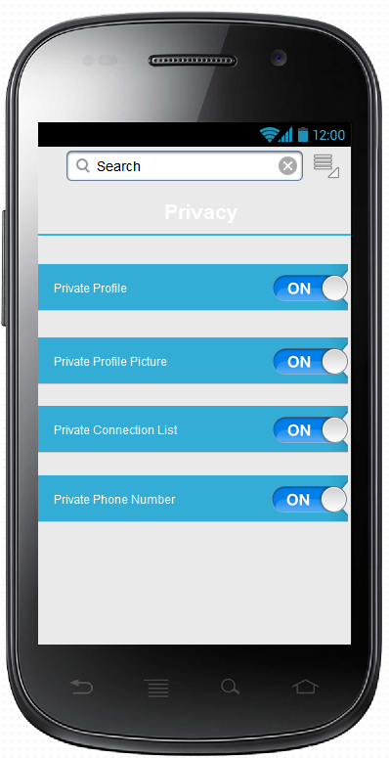**Settings-Privacy**

From privacy settings, users can arrange their privact preferences.

If a user makes its profile private, other people must send a connection request in order to user’s schedule.

If a user makes its profile picture private it means that nobody can see its profile picture in big size(there must be a picture which cannot be zoom in)

If a user makes its connection list private, it means that other people cannot see user’s connection list.

If a user makes its phone number private it means that other people cannot see user’s phone number.

The general idea is the same in privacy setting as we can see.

It is a working in progress, therefore there would be more privacy options in next days.

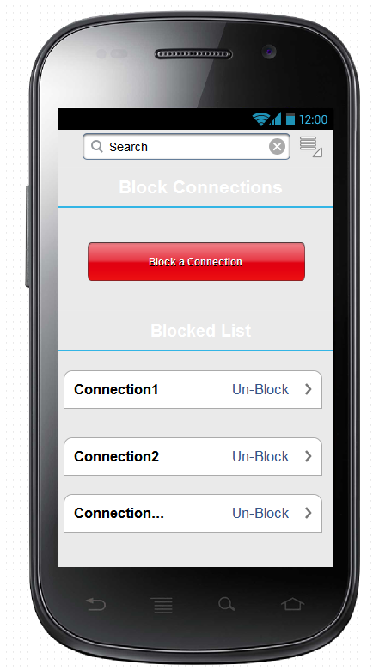**Settings- Block Connection**

It is a fact that there are a lot of threats and disturbing occasions on social networks, thus user may need a block function which allows them to block some users who disturb them. As we can see from the picture there is a list below the page which contains the list of blocked users. If user wants to remove the block, user must select the un-block button. Moreover, if a user wants to add a user to the blocked list, user must select the “Block a Connection” button and than user must write the name of the connection.

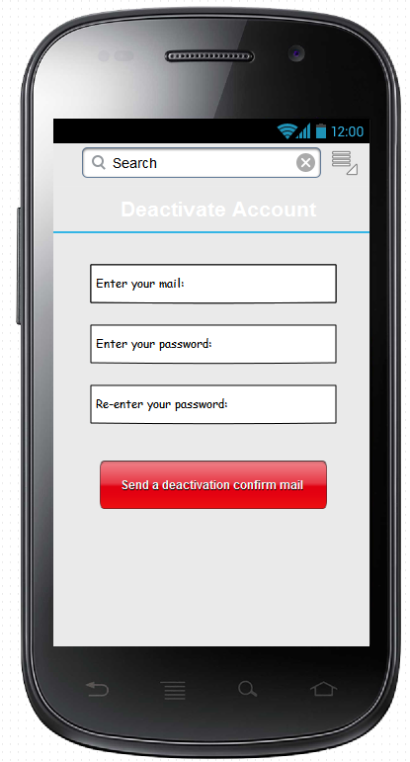

**Settings - Deactivate the Account**

If a user wants to deactivate his/her account. The user must enter his mail and password(2 times). After that user must click the “Send a deactivation confirm mail” which will sent a deactivation confirmation mail to the user’s Bilkent mail adress.If user confirms the mail, the account will be deactivated until user enters the his/her account next time. To understand why the user deactivates his/her account we might ask some questions to the user about the application.

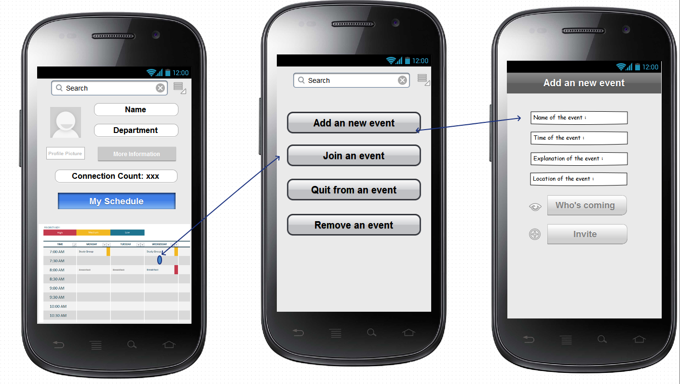

**Navigation Bar- Events- Add an new Event**

**Schedule – Add an new Event**

As we can see from the picture at the top, to add an event we can select a available time period and we can wee different choices which helps us to arrange our free time. If a user wants to add an new event, he/she must enter the name, location, time of the event and user must briefly give some explations about the event. After that user can see who is coming to the event and user can also invite other connections. This “add event” function can be also access from events section from navigation bar.

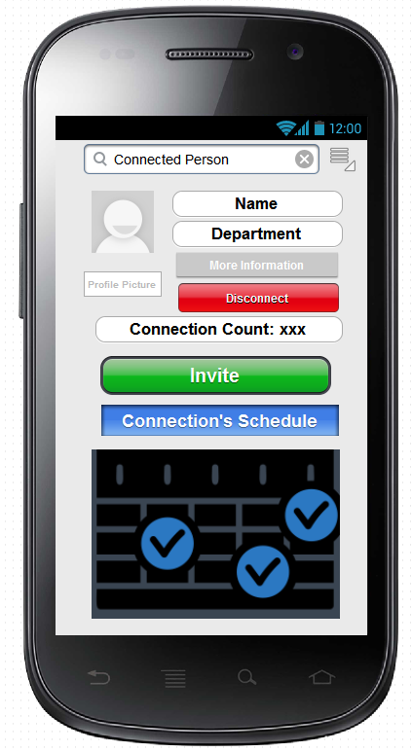**Connected Person**

When one connection is choosen from the Connection List or searched from seek bar his/her page is visible.

The information about her can be seen as it is seen on the User’s Page but there some differences. There is a “Disconnect” button which do the work which is the same as “Disconnect” of Connection List do.

The “Invite” button is also a difference. It is used for the user to invite this connected person to an event.

The schedule shows when this connected person is free.( By the tic icon)

User can see the connection count the connected person if it is not private.

User can also see some more informations about the connected person if it is not private too.

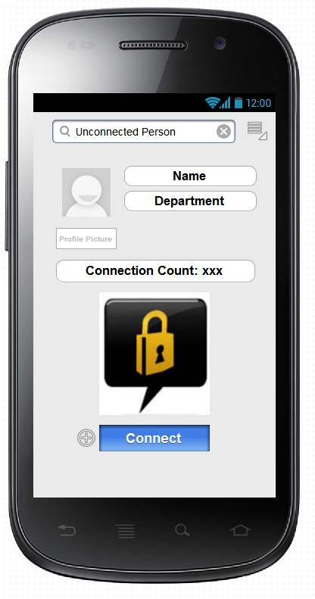

**Unconnected Person**

The information in this page is limited. This unconnected person’s schedule can never be seen until (s)he is connected.

User just can see some basic information about the unconnected person such as name, department and connection count (if it is not private).

User can send a connection request to the unconnected person by clicking “Connect” button.

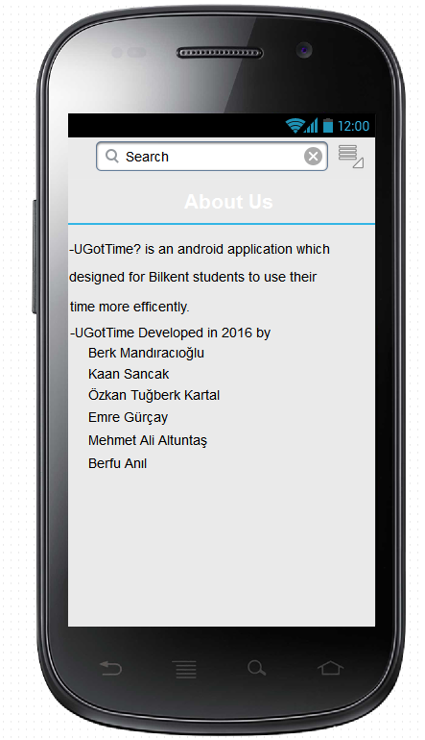**Settings- About Us**

Users can find some basic information about us and our application by selecting “About Us” from the settings (from navigation bar).

About us contains information about developers of the application.

It is a working in progress since the application is not over yet.

# Summary & Conclusions

And finally… don’t forget that Word can help to check your spelling (and grammar!)

Maintaining lists of research references that can be reused when writing journal articles can be a real pain, especially when citation styles vary so much from journal to journal. When you have time I suggest you look at reference managers (e.g. JabRef for BibTeX, or websites such as CiteSeer), as well as other document creation options (e.g. LyX, LateX and OpenOffice.)

Good Luck.